**Cloud :**

**EC2 instances is the elastic cloud instance which is provided by AWS(Amazon Web Services). Amazon is one the big giants to offer cloud services.**

**For creating New instances, firstly one should have an AWS account of free tier.**

**so , lets dive into creating ec2 instance**

***This is the “Home Page of the AWS”***

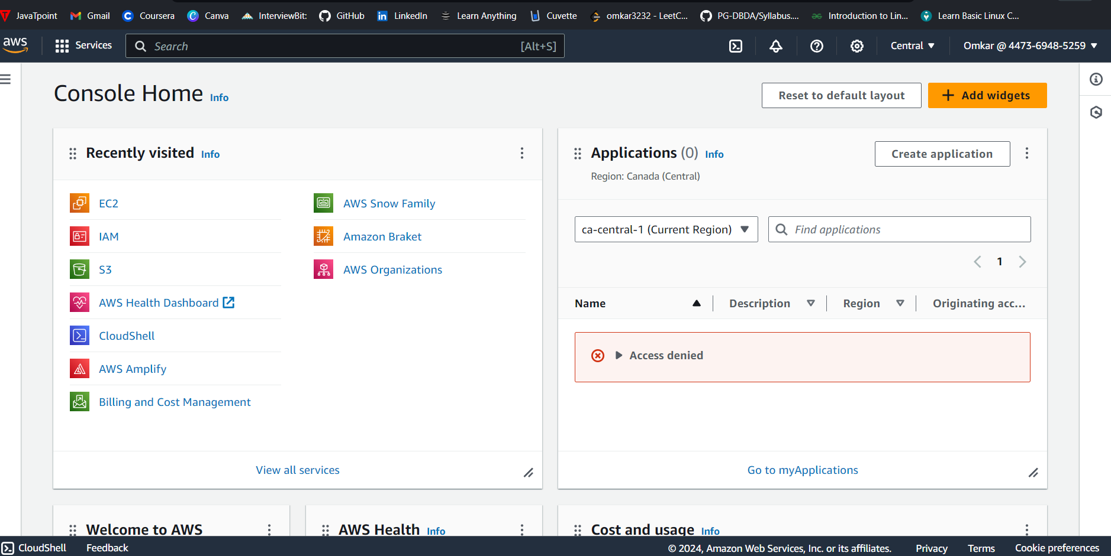

**Search on the “Menu Bar” EC2**

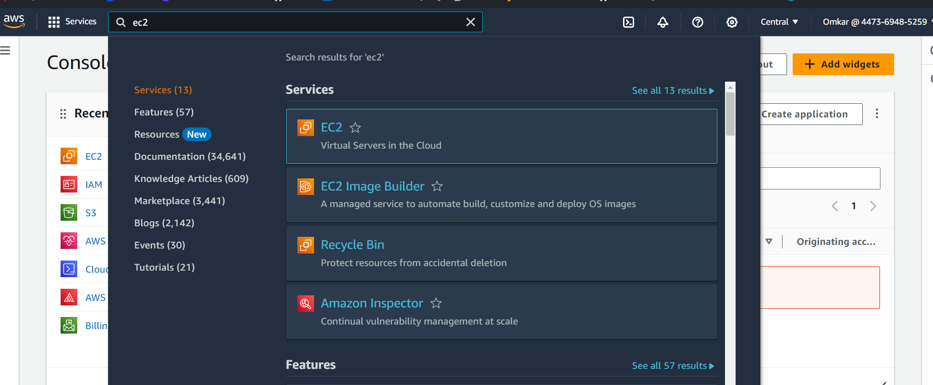

**Click on ec2 you will land on the page given below ⬇️**

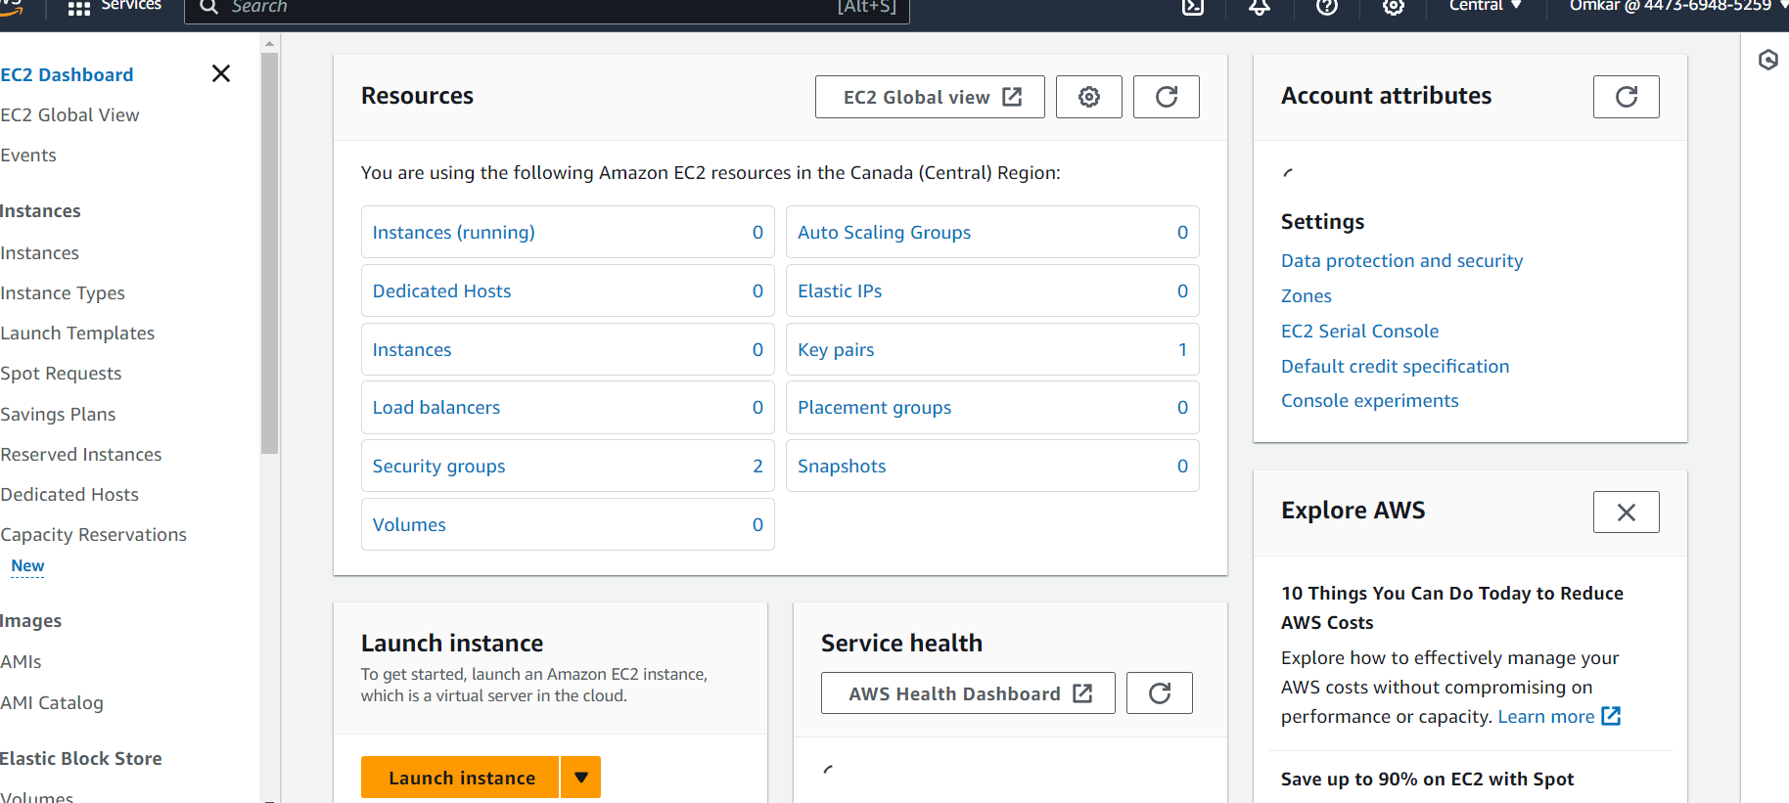

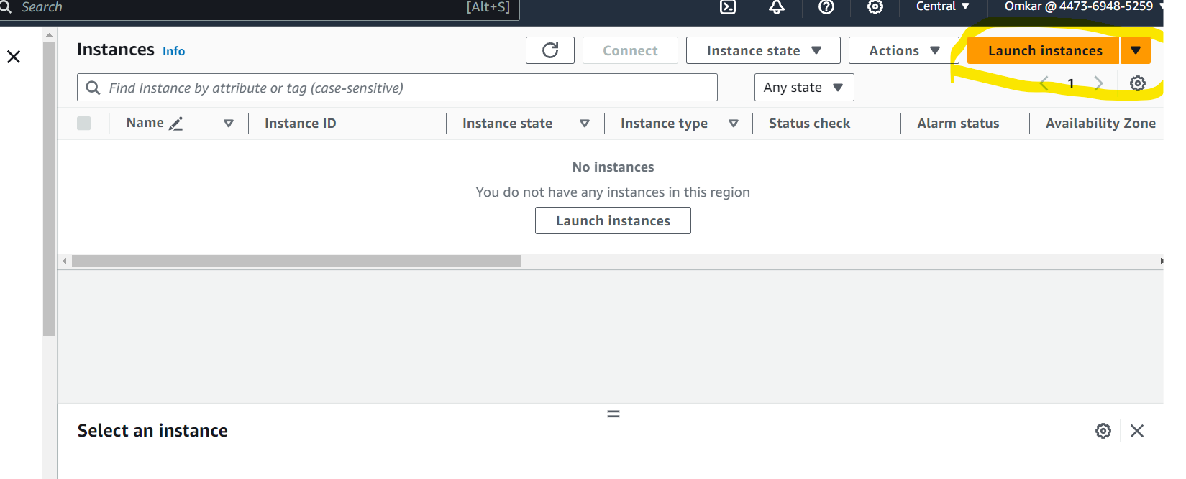

**Click on “Launch instance”**

**Give the name to you instance and select amazon linux. Below is the image**

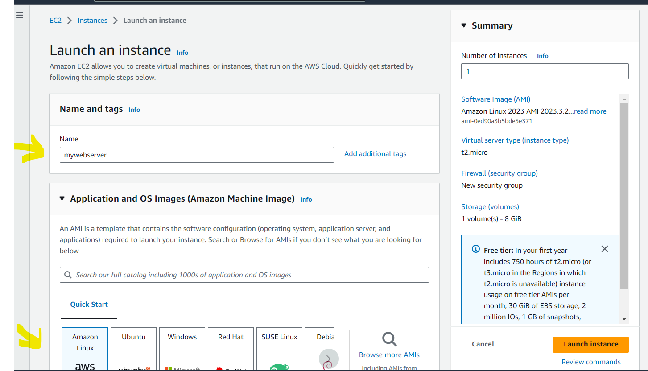

**Use t.micro “Free tier eligible” in the instance type or else will get charges. Click on the “create new key pair”** 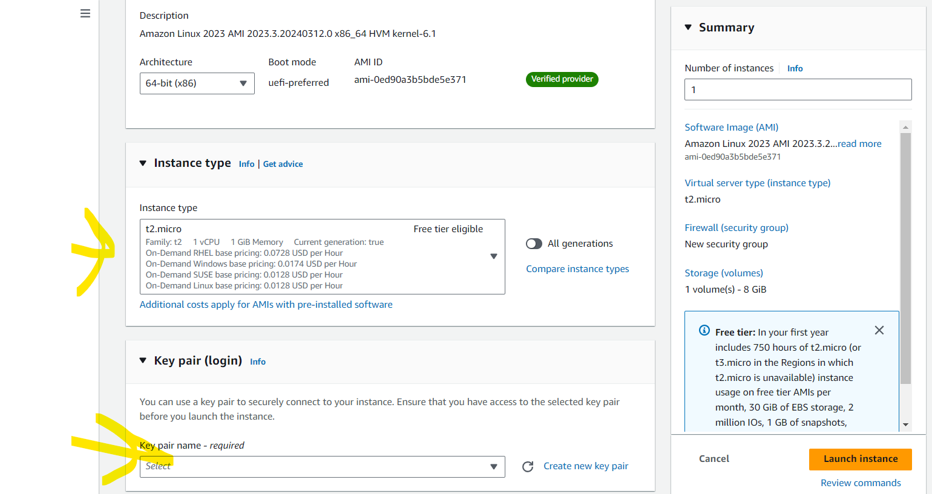

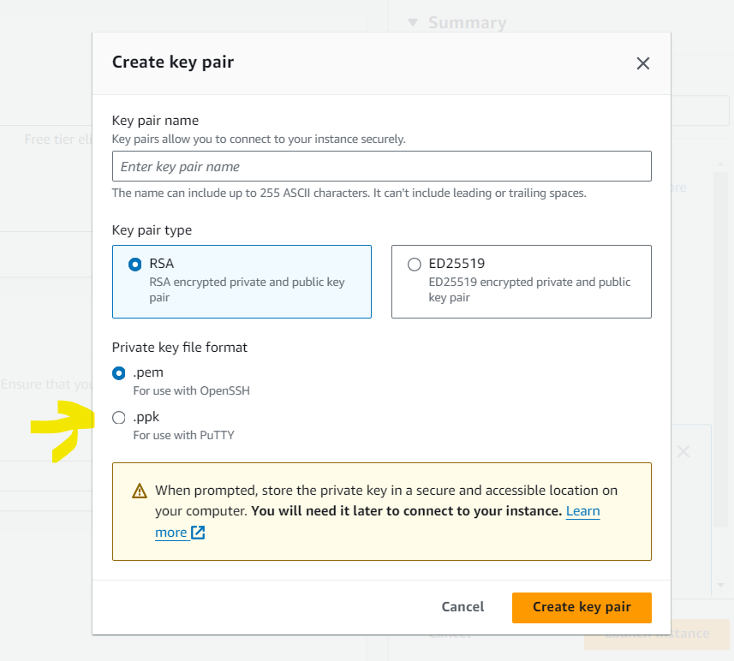

**Create a new key pair, keep key pair type “RSA”**

**Choose the Private key file format to “.ppk” and click on create key pair.**

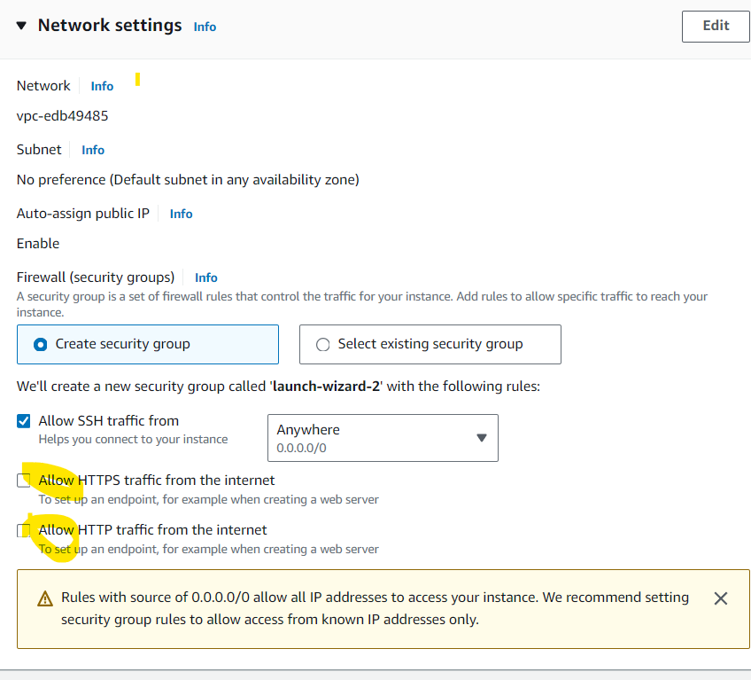

**Allow all the check box**

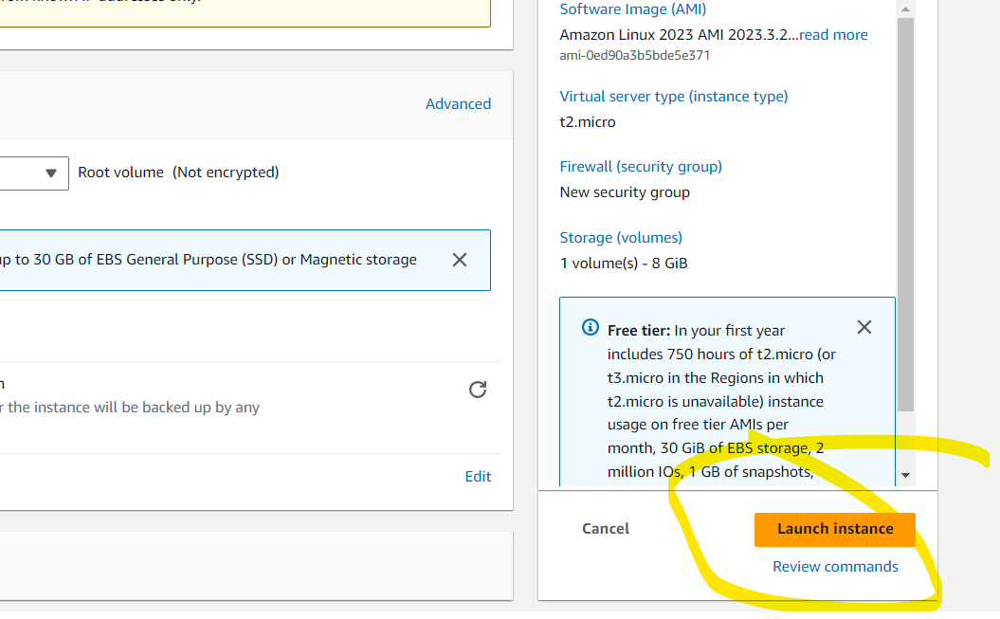

**Launch the instance**

**Now After that store the key to your local compute and the open install PUTTY and open it .**

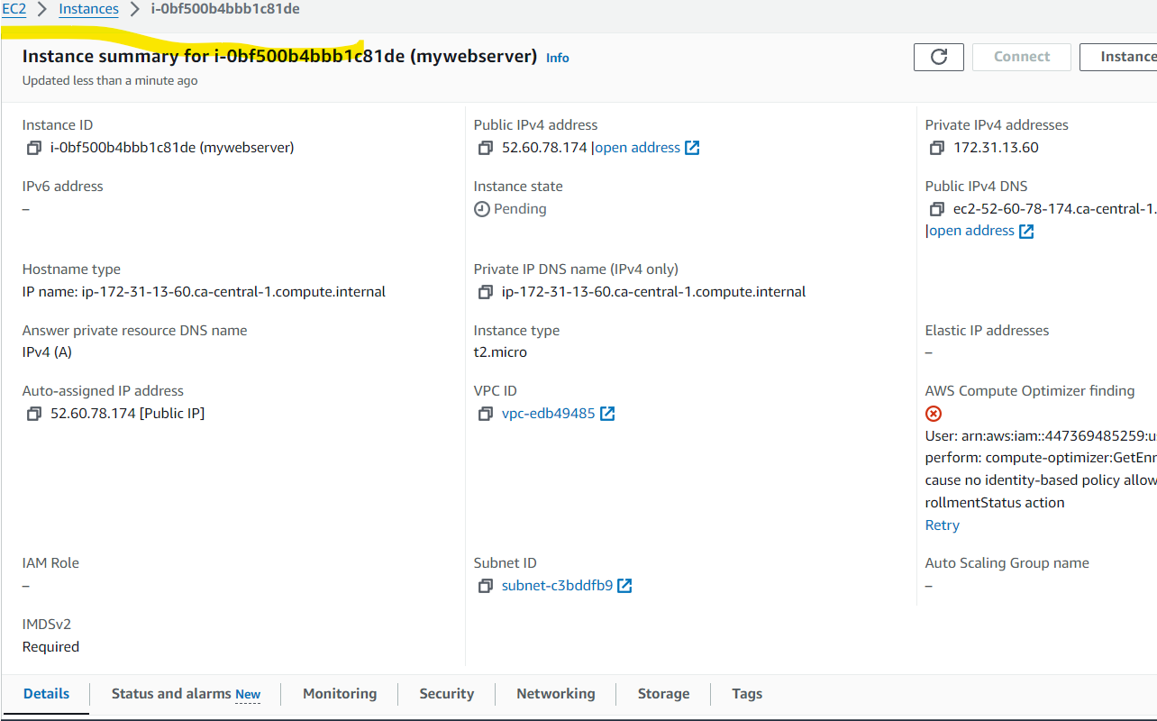

**Copy the “Public IPV4 address and open putty on your pc**

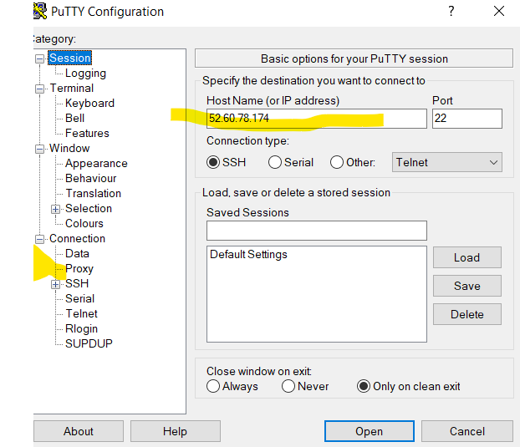

**Paste the IP address on the “bar shown in highlighted area.**

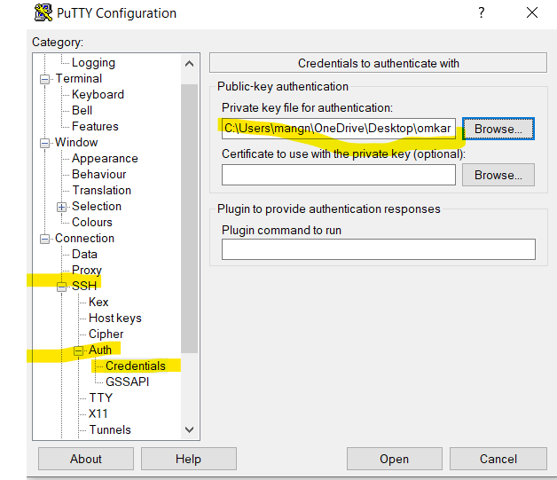

**Go to SSH then Auth then Cedential and the browse your key which was created earlier.**

**Then click OPEN and the accept and continue you will see this tab.**

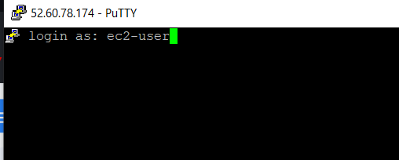

**Type ec2-user and enter.**

**You will be show this message.**

**Write sudo -i command for the root being root user**

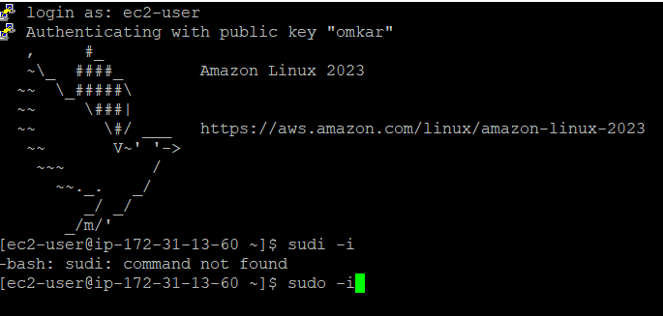

**Give command you install httpd -y. To install the httpd in to pc. -y is for YES.**

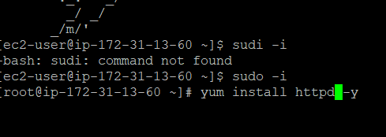

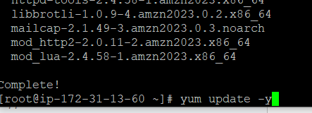

**Now update it with “yum update -y command**

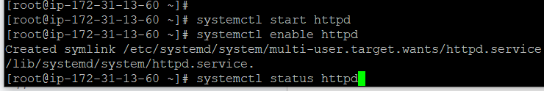

**Type this commmads : ‘systemctl start httpd’ and then ‘systemctl status httpd’ then ‘systemctl enable httpd’**

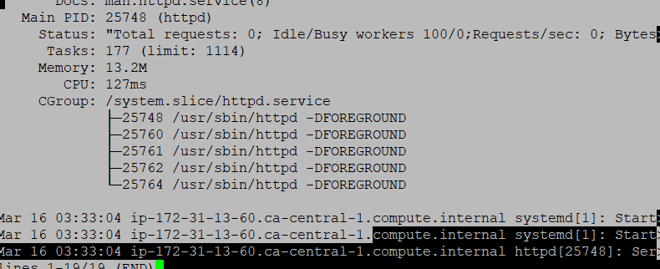

**Enter this to change directory to html.**

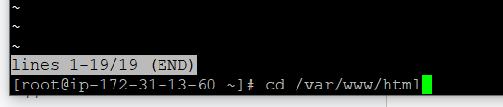

**Use nano index.html to create a file.**

**Write any simple text in it and the save it with ctrl-y command and view its contents with cat index.html command.**

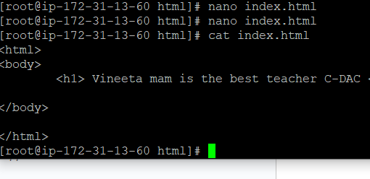

**Then copy the ip address to the new tab and you will be able to see the content of the file.**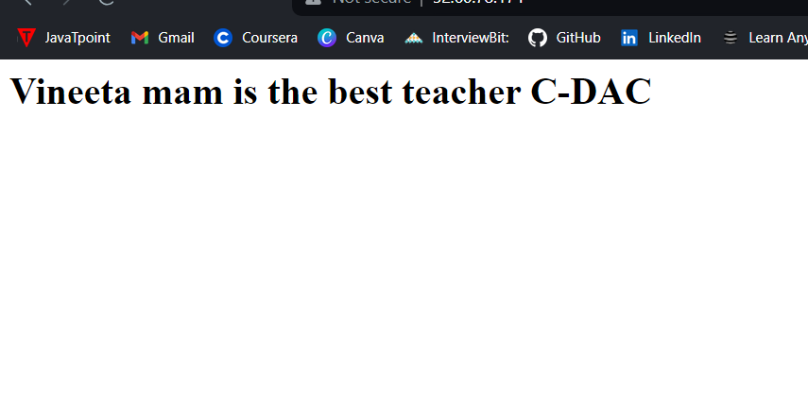

**Thats it you have created instances successfully.**

**Creating the s3 bucket for uploading the file in it.**

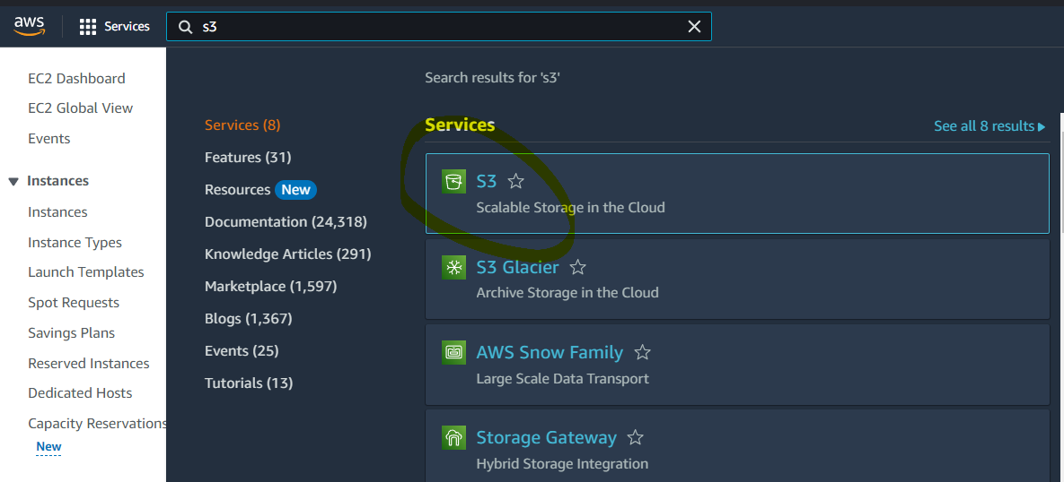

**Select the s3**

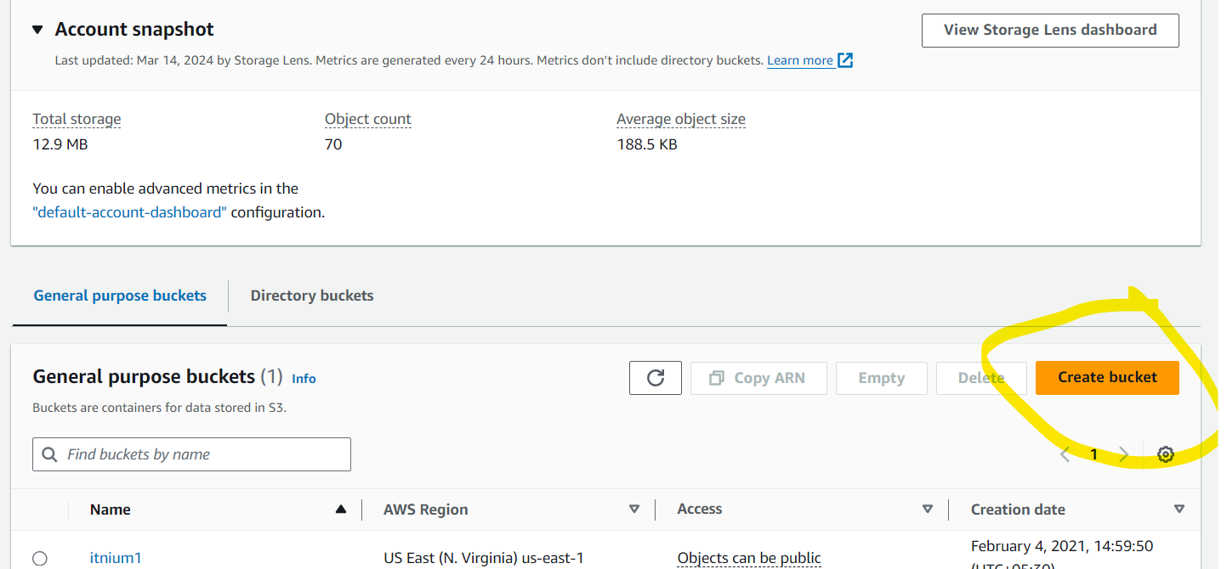

**Click on the “create bucket”**

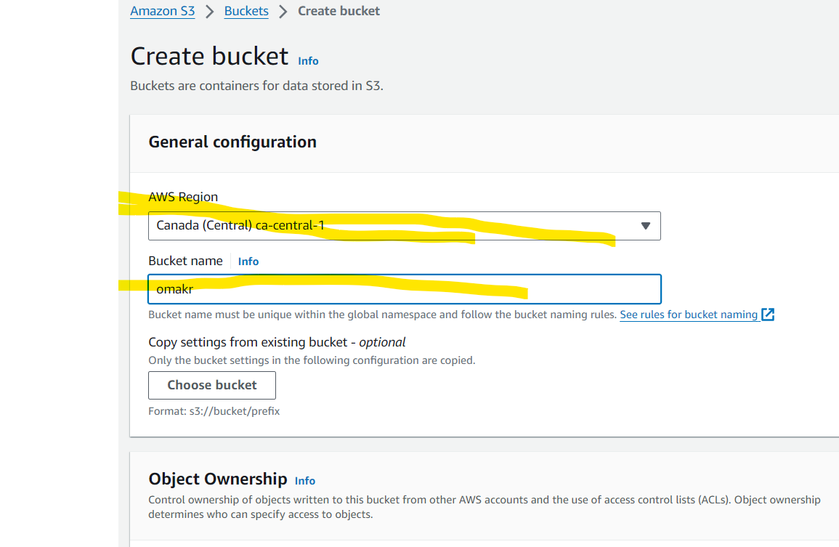

**Select the “AWS Region”**

**AND**

**Select the bucket name as per u r wish**

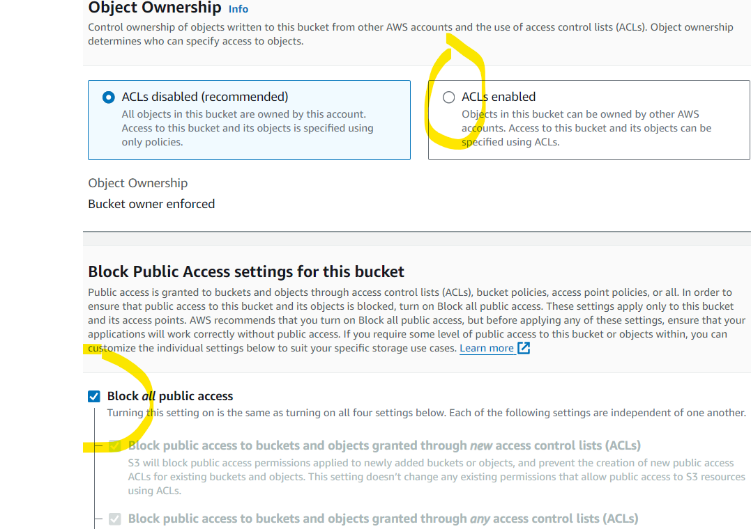

**Enable the Acl enable box and Untick the Block off public access.**

**Accept this term**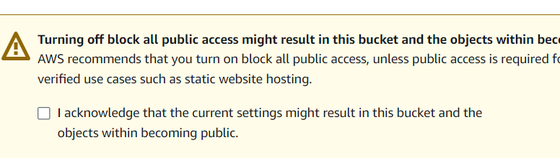

**Let Everything be default and click on Create bucket**

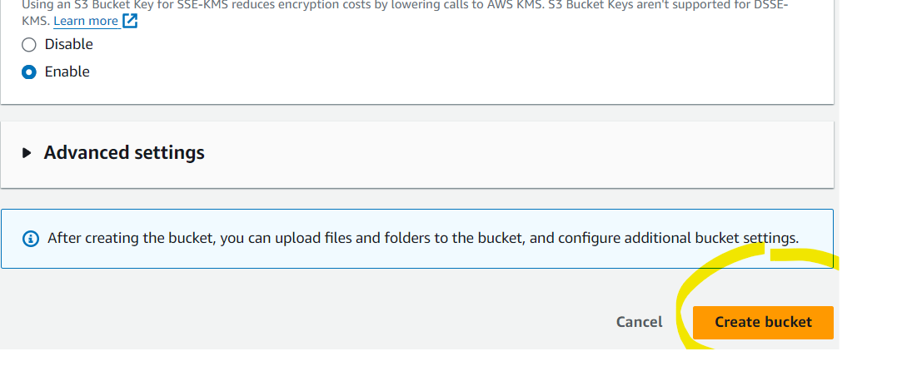

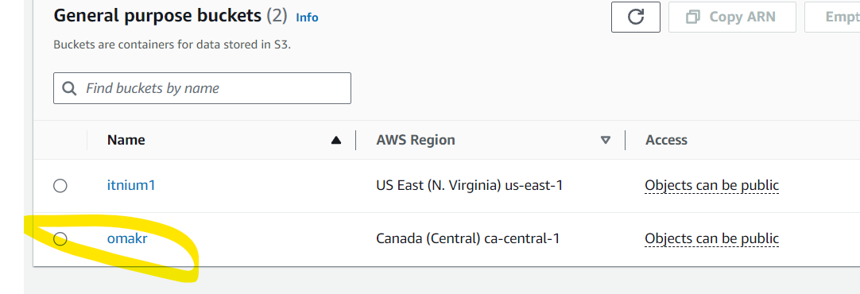

**You have successfully created bucket and now its time to upload an image in it.**

**Click on upload button to upload any image on your computer.**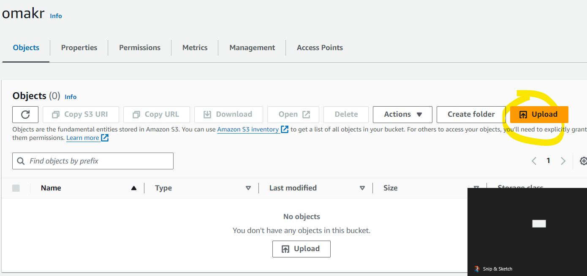

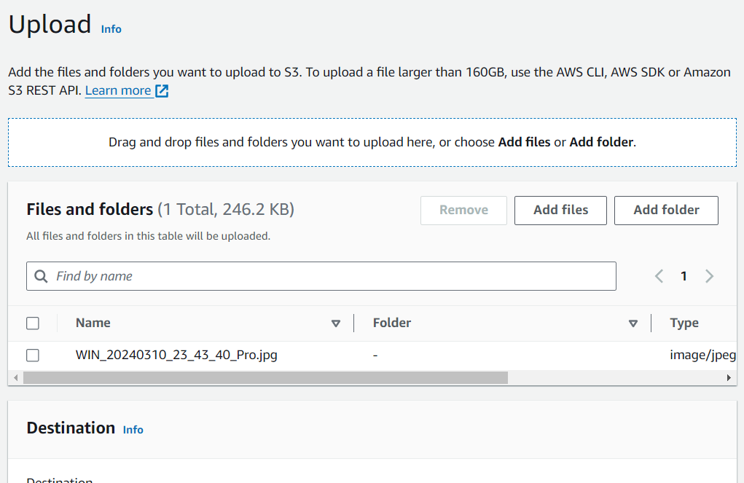

**Now the image is uploaded in bucket.**

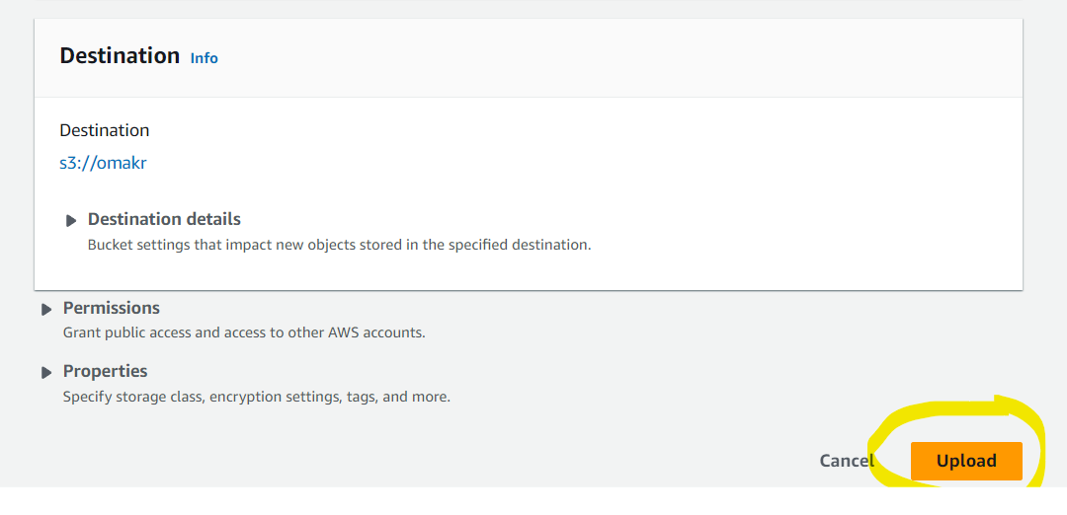

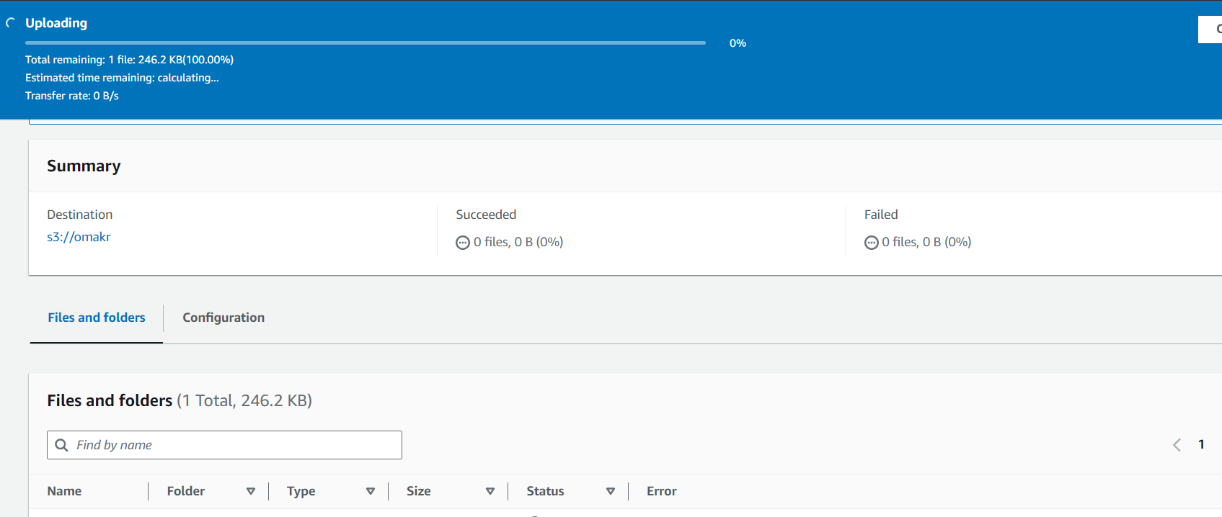

**Click on the image copy the http url and paste it on the browser new tab to view the image.**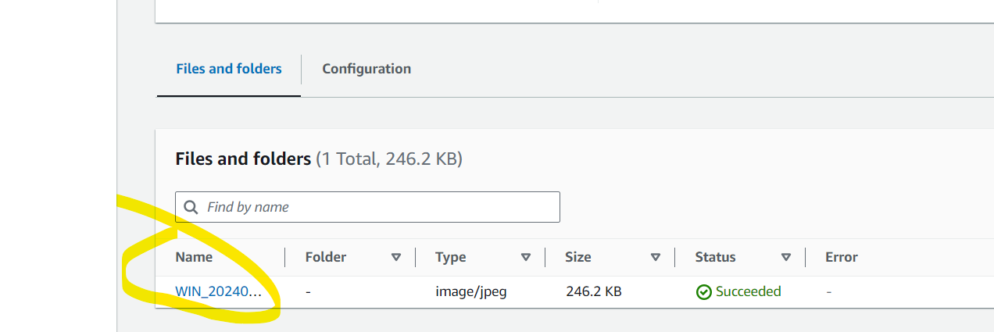

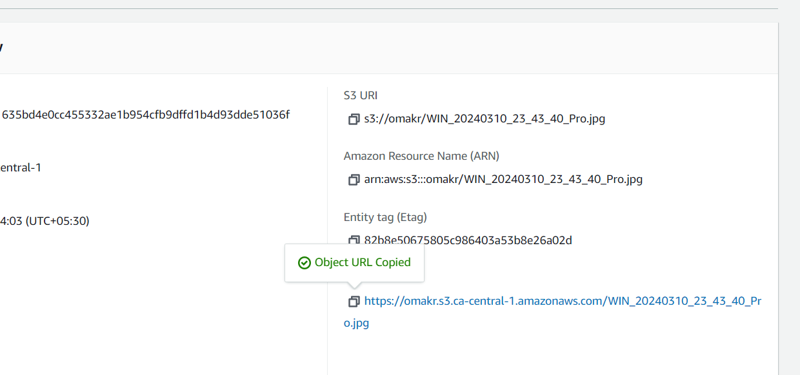

**If the image is not displayed on the tab then enable the Access control settings(ACL)**

**Tap to edit the settings**

**And tick the box**

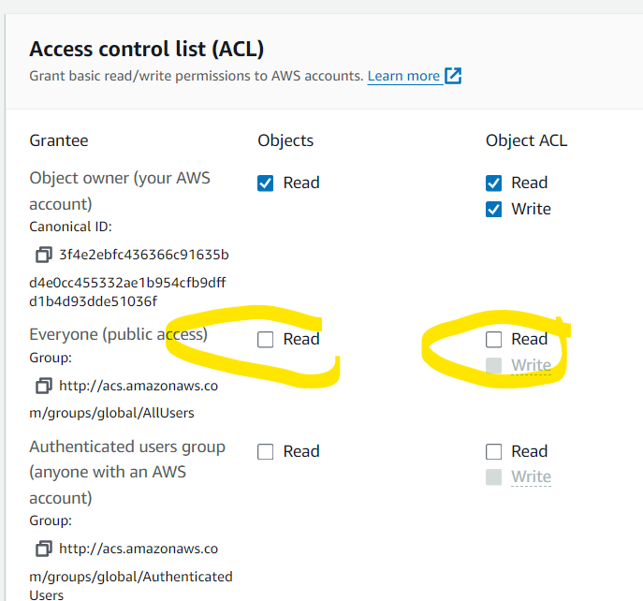

**Select the box and “save changes”**

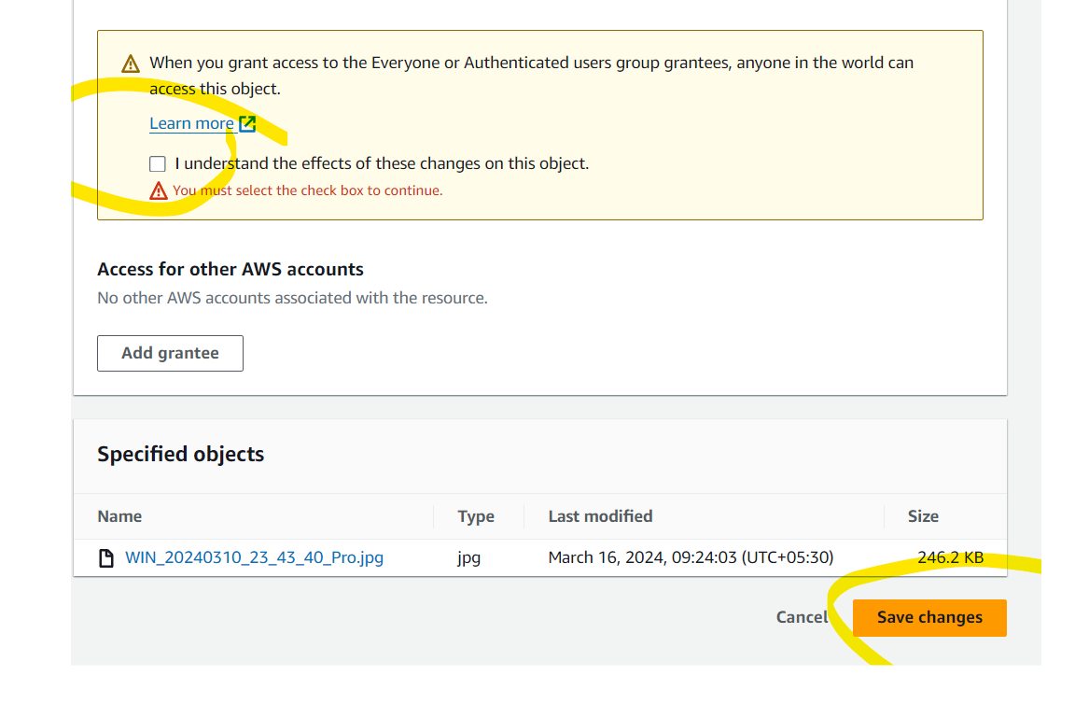

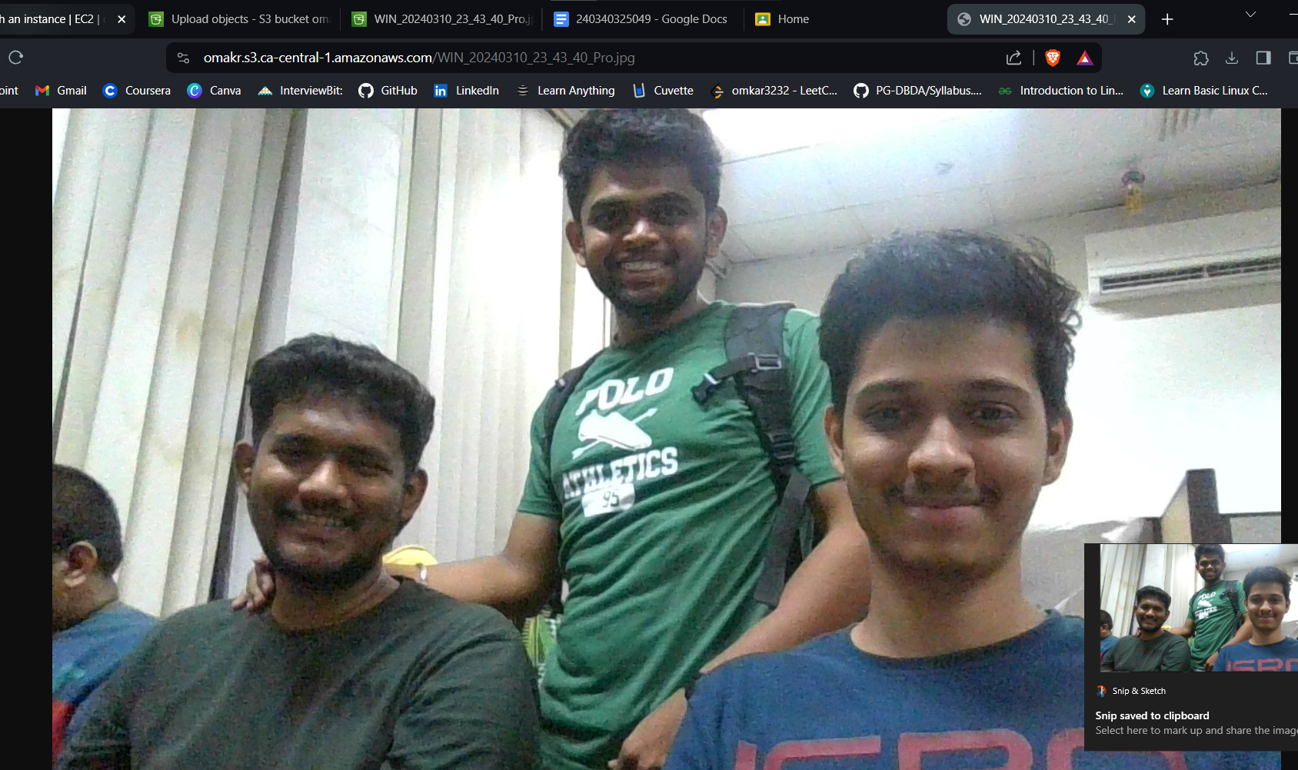

**Here is your image which is being uploaded on the bucket.**

**Shell commands:**

**Write a shell script to display ……**

**1. Date - for displaying the date and current in the terminal**

**2. cal - for the calender of the current year.**

**3. Ls- for the listing all the firectories you have.**

**4. Pwd - is there to view your present working directory**

**5.Exit - is for exiting form the terminal.**

